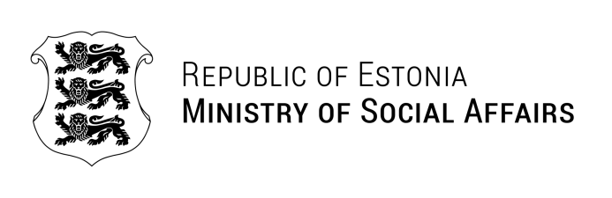
Our ref. 08.04.2024 | No 1.6-9/924-1

Letter of confirmation

Dear Sir/Madam

This is to confirm that Siiri Aulik was employed in the Ministry of Social Affairs as a Project Manager and Adviser in the Social Welfare Department from July 2013-December 2014 and in the Equality Policy Department as an Adviser from January 2011-February 2012.

In the Social Welfare Department, she was employed as the Project Manager of European Social Fund project “Social welfare services in support of employment 2012-2013”, which was extended into 2014. Her tasks included managing, monitoring and reporting on project activities, procurement of services, responsibility for informational materials and presenting project results to stakeholders. She also advised on policy relating to older persons and age discrimination, and contributed to reporting on implementation of the UNCRPD in Estonia.

In the Equality Policy Department, she was an adviser on gender equality and non-discrimination law and policy, where her tasks included consultation and communication of policy with civil society organisations and other stakeholders.

Yours sincerely,

Kairi Nodapera
Human Resources Manager

Edith Kallaste
Edith.Kallaste@sm.ee

